Web Services

**REST:**

REST (Representational State Transfer) is an API that defines a set of functions that programmers can use to send requests and

receive responses using the HTTP protocol methods such as GET and POST.

**REST api vs RESTful api:**

"REST API" is a broader term that could refer to any API that uses the principles of REST, but it might not adhere to all the principles strictly.

"RESTful API" specifically refers to an API that strictly follows the principles of REST.

**HTTP Protocol methods**

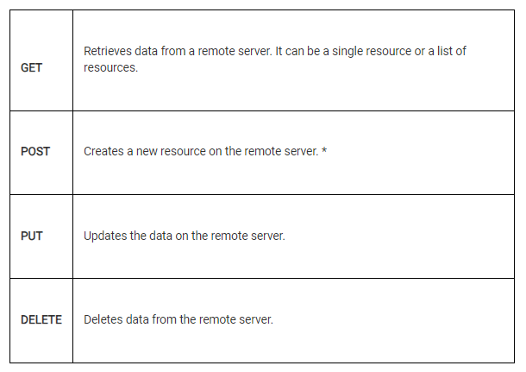

**HTTP Headers:**

Headers provide additional information about the request or response and help in controlling the behaviour of the communication between the client and the server.

**User-Agent:**

Provides information about the client's software, such as the web browser or application making the request.

**Accept**:

Informs the server about the preferred format of the response data that the client can handle.

**Host**:

The Host header is an essential HTTP header used to indicate the domain name of the target server that the client wants to communicate with.

**Accept-Encoding:**

The Accept-Encoding header is an HTTP request header that a client sends to a server to indicate the types of encoding that the client can understand and accept in the response.

**Connection:**

The Connection header is an HTTP header used to specify options for the current connection between the client and the server.

**Authorization:**

Used to send authentication credentials, such as tokens or username/password combinations, to access protected resources on the server.

**HTTP Params:**

HTTP parameters, also commonly referred to as query parameters or URL parameters, are key-value pairs included in the URL of an HTTP request. They are used to provide additional information to the server or to customize the behavior of the request. Parameters are typically included in the query string of the URL after the question mark (?) and separated by ampersands (&).

**HTTP Body:**

The HTTP body, also referred to as the request body or response body, is the part of an HTTP message that carries the payload data sent between the client and the server.

**Content-Type:**

Specifies the format of the data sent in the request body, such as application/json or application/xml.

**Status code:**

HTTP status codes are three-digit numbers sent by a web server in response to a client's request. They provide information about the outcome of the request and help both clients and servers understand how to handle the response.

Informational responses (100 – 199)

Successful responses (200 – 299)

Redirection messages (300 – 399)

Client error responses (400 – 499)

Server error responses (500 – 599)